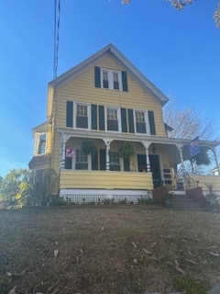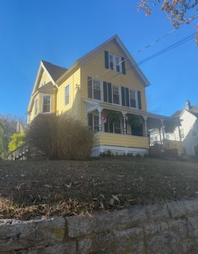

The residence at 175 Montauk Avenue was constructed in 1905 for Henry Lulfler, on land he purchased in 1894. At the end of the 19th and early 20th centuries, the land on which the residence is sited began to be improved with the subdivision’s platting and provision for water mains and electric streetcar tracks. The house is just outside, and to the east of the boundaries of the Montauk Avenue Historic District listed in the National Register of Historic Places in December, 1990. The residence at 175 Montauk is flanked on either side by two, larger multifamily residences of about the same vintage.

In New London, on what had previously been farm land before the turn of the 20th century, this “streetcar suburb” was designed for its homogeneity in both the house and lot sizes; the uniformity of the setbacks, and the planting of street trees. In close proximity, often referred to as the Willetts Avenue neighborhood, are landscape elements such as pocket parks and wide medians. The “suburb” was intended to remove the new residents from an often dense and paved urban environment, into a more sylvan, green open space. The architectural designs, often executed by carpenter builders, were derivative in style, often reflecting the historicism of earlier decades.

Henry Lufler (1848-1910) the original owner of the Montauk Avenue residence was born in Massachusetts and later moved to Stafford, Tolland County, Connecticut. For many years Lufler, a machinist, was employed by the D.E. Whiton Machine Company, and upon his move to New London, was a supervisor of the tool shop.[1] Lufler, a Republican, was heavily involved in politics, and while in Stafford represented the town in the general assembly. His leadership extended during his 25-year residency in New London as he served several years as a delegate to the probate convention. While in the employ of the Whiton Company, Lufler was a leader in the Whiton Mutual Aid and Benefit Association, becoming

its president between 1904-1905[2]. He was married to L. Rosalia and had one son, named Forrest D. Lufler.

Besides his engagement in politics and the Mutual Benefit Society, Henry Lufler was a luminary in the First Church of Christ (Congregational) located at the corner of State and Union Streets at the turn of the 20th c. He was especially committed to youth activities as a leader in the YMCA and as a Sunday School teacher and Deacon of the church. The Sunday School met in the Bethany Chapel, and Lufler was named its Superintendent from 1903 until 1907.[3]

After Henry’s death in 1910, Mrs. Lufler sold the home to Raymond Burrows in 1914. The chain of subsequent owners is as follows:

Patrick Kenure 1915

Margaret Kenure 1935

Natalie Higbee, Margaret and Mary E. Kenure , 1960

Rose Mary Ward, 1975

Charles B. and Amelia M. Nye, 1976

Denise K. and Douglas J. Goodman, 1995

Dorothy A. and Willliam R. Salen, 1999

David W. Craddock and Cathlene J. Hutchings, 2002

Sited on a steep embankment facing east and occupying the middle lot on a block flanked by homes of similar design and vintage, the residence was originally built as a single-family home and was later converted into a multi-family dwelling. The design of the home is most aptly described as “American Foursquare” characterized by its 2 ½ story height, rectangular plan, intersecting gable roofs and full width front porch. The shed roof of the porch is supported by slender wooden posts that possess a spindle profile and terminate in a decorative wooden capital. The porch posts and capitals are reminiscent of the more elaborate Queen Anne design.

1. “Obituary, Henry Lufler” *The Norwich Bulletin*, December 10, 1910. P.11
2. During the early 20th century., at a time of rapid urbanization across America and before the advent of institutionalized government welfare programs, Mutual Aid societies were formed as practical way for individuals with common interests or professional associations to provide support and assistance to their membership. Usually funded by dues, the society would provide financial assistance to their members during times of hardship and sickness.
3. The Bethany Chapel is reported to have been located on Bank Street near Ocean Avenue. ( *The New London Day*, March 5, 1904, p.3)